**Working Paper 1**

Version 3 (WP1.3)

17th September 2021

Author

Dr.Thanapon Piman, SEI

Chinaporn Meechaiya, ADPC

**Documentary**

|  |  |  |  |
| --- | --- | --- | --- |
| **No** | **Documentary** | **Purpose** | **Date** |
| 1 | Concept note: The RAT Mekong | To present the concept to the 7th EGDMF for agreement | 26 Feb 2021 |
| 2 | The RAT-Mekong: WP1.1 | To present preliminary selection of reservoirs for the RAT-Mekong to the MRCS | 10 Sep 2021 |
| 3 | The RAT-Mekong: WP1.2 | To present selection results of reservoirs for the RAT-Mekong to the 8th EGDMF for agreement | 2 Sep 2021 |
| 4 | The RAT-Mekong: WP1.3 | To address comments on the list of reservoir selection from the 8th EGDMF | 15 Sep 2021 |

**Developer team**

|  |  |  |  |
| --- | --- | --- | --- |
| **No** | **Name** | **Organization** | **Email** |
| 1 | Prof. Faisal Hossain | University of Washington | fhossain@uw.edu |
| 2 | Mr. Pritam Das Graduate | University of Washington | pdas47@uw.edu |
| 3 | Prof. Hyongki Lee | University of Houston | hlee45@central.uh.edu |
| 4 | Chinaporn Meechaiya | ADPC | chinaporn.m@adpc.net |
| 5 | Md. Kamal Hosen | ADPC | kamal.hosen@adpc.net |
| 6 | Dr.Thanapon Piman | Stockholm Environment Institute | thanapon.piman@sei.org |
| 7 | Uttam Ghimire | Stockholm Environment Institute | uttam.ghimire@sei.org |





Table of Contents

1. Background 4

2. Objectives of the RAT-Mekong 4

3. Objectives of the WP1 5

4. Selection of the reservoirs for testing and developing the RAT-Mekong 5

4.1 Methodology 5

4.2 Selection criteria 6

4.3 Data use to consider in the selection process 7

4.4 Results of the selection 13

5. Design of web-interface (1st mockup) 14

6. Capacity building programme 15

7. Work Plan 16

8. References 17

Annex A: Comparison analysis of the RAT-Mekong (SERVIR-Mekong) and the Mekong Dam Monitor (Stimson Center) 18

Annex B: Multi-criteria analysis for ranking and selecting reservoirs 20

# Background

SERVIR-Mekong (<https://servir.adpc.net/>) works in partnership with leading regional organizations to help the five countries in the Lower Mekong Region use information provided by Earth observing satellites and geospatial technologies to manage climate risks. The region includes Cambodia, Lao PDR, Myanmar (Burma), Thailand and Vietnam. The Asian Disaster Preparedness Center (ADPC), a recognized leader in strengthening disaster resilience in Asia, is the prime implementer for SERVIR-Mekong. Three other consortium partners, Spatial Informatics Group (SIG), Stockholm Environment Institute (SEI) and Deltares, assist in implementing the SERVIR-Mekong program and bring exceptional capabilities to help deliver services to the region.

**R**eservoir **A**ssessment **T**ool for Lower **Mekong** Basin (**RAT-Mekong**) under the SERVIR-Mekong program is developing to support information on reservoir monitoring to the MRC and its member countries in decision making and planning processes for flood and drought management in the Lower Mekong Basin (LMB). **The RAT-Mekong is Near Real-Time reservoir monitoring tool using satellite observations and hydrologic model** (Biswas et al 2021). The tool will fill the data gap in reservoir monitoring at the basin scale due to limited in-situ data and restriction of data-sharing policy. At present, reservoir information in the Upper and Lower Mekong Basins is important for drought and flood management downstream.

The RAT-Mekong will support the MRC in development of indicator monitoring of the MRC’s Drought Management Strategy (DMS) 2020-2025 which is referred to reservoir monitoring indicator as well as MRC’s Flood Management and Mitigation (FMM) Strategy 2021-2030. The tool has been identified in the MRC Multiyear work plan 2021-20222 under task 4.1.4.1.7 Develop reservoir assessment tools with ADPC and other partners. Moreover, the reservoir information such as estimated inflows, outflows and storage changes from the RAT-Mekong have potential to support and facilitate implementation of the MRC Procedures including for Procedure of Data Information Exchange and Sharing (PDIES), Procedure for Water Use Monitoring (PWUP) and Procedure for the Maintenance of Flow on the Mainstream (PMFM) of the Mekong River.

The concept note of the RAT-Mekong is presented to the 7th Regional Expert Group Meeting on Data Modelling and Forecasting (EGDFM) on 3rd March 2021. The member countries acknowledged and approved the RAT-Mekong after the Expert Group Meeting to develop a tool to monitor Near Real-time (bi-weekly) reservoir behavior and reservoir operating rules based on long term records are made available to the public, which can be helpful in data-scarce, or data restricted in the basin.

# Objectives of the RAT-Mekong

The overall objective of the RAT-Mekong ***is to provide near-real-time reservoir monitoring information to assist the MRCS and Member Countries in decision and planning process for drought and flood management in the Lower Mekong Basin***. Followings are specific objectives of this tool development.

1. To regularly estimate changes in reservoir storage, surface area, inflow, outflows, and inferred reservoir rule curve (Bonnema et al. 2016; 2017).
2. To develop a user-friendly web-interface system to share reservoir monitoring information and integrate into MRC data portal for MRC and relevant users in the Member Countries.
3. To support MRC to develop reservoir monitoring indicators for decision making and planning in drought and flood management.
4. To build capacity of the MRCS and Member Countries to enhance reservoir assessment capability using satellite observations and the hydrologic model.

# Objectives of the WP1

The technical team of the MRC suggested the SERVIR-Mekong team to develop criteria and identify reservoirs for the RAT-Mekong to present to the member countries for approval. On 8 April 2021, The SERVIR-Mekong team has organized the technical meeting with the MRCS team to present and discuss on the criteria for the reservoir selection. Key criteria have been identified according to the suggestions from the MRCS. The MRCS team has provided the updated hydropower and irrigation database to the SERVIR-Mekong team to support selection of the reservoir on 6th June 2021.

**The main objective of this working paper is to present the results of selection of reservoirs for developing the RAT-Mekong in the testing phase to the MRCS team and the Member Countries to seek inputs, suggestions, and agreement**. The WP1 also presents the 1st mockup of the Mekong-RAT web-interface as well as tentative plan for capacity building program and workplan. In Annex A of the WP1, we have compared the RAT-Mekong and Dam Monitoring Tool that is developed by Stimson Center as requested by the MRCS team to clarify the differences.

# Selection of the reservoirs for testing and developing the RAT-Mekong

## Methodology

**A multi-criteria method** is used to rank and select the reservoirs in the Mekong Countries for the RAT-Mekong according to agreed criteria with the MRC. Followings are key steps for the analysis.

**Step 1: Define criteria for selection**

Key criteria to rank and select the reservoirs for the RAT-Mekong are defined through consultation with the MRCS team. The selected criteria are presented in Section 4.2

**Step 2: Define criteria weights**

Weighted sum method is selected for the analysis. Equal weight is applied for all selected criteria.

**Step 3: Assign scores**

Scoring is assigned by the expert view from the SERVIR-Mekong team through considering data in Section 4.3 and in consulting with the MRCS technical team. Score is vary from 1-5 (1 is not agree with the criteria and 5 is fully agree with the criteria)

**Step 4: Compute the matrix of alternative scores and ranking**

Utilising the vectors of criteria weights and the matrix of criteria scores, a global score and hence ranking for each reservoir is calculated using:



where: *a* is the reservoir, *c* is the criteria, *g* is the global score of the alternative, *w* is the criteria weight and *s* is the criteria score. A function of the ranking equation, aggregating across each criteria means that trade-offs between criteria in fundamental to the final ranking. The results of ranking are presented in the **Annex B**.

## Selection criteria

Followings are four key criteria to rank and select the reservoirs for the RAT-Mekong based on agreement with the MRCS, RFDMC, and SERVIR-Mekong in the technical meeting in April 2021.

1. Considering availability of satellite data and modelling feasibility
2. Considering storage reservoir type with large and medium storage capacity (> 10 mil m3) with have significant benefits to flood and drought management.
3. Considering irrigation areas downstream
4. Considering impact between upstream and downstream of reservoirs

The MRCS team also suggest considering balancing of reservoir numbers across the Member Countries. **Based on technical discussion with the MRCS technical team that we should start from the small number of reservoirs in the testing phase according to data, time, and resources constraints, therefore, we purposed to select three reservoirs for each Member Countries**. In total is about 12 reservoirs in the LMB. This number is enough to demonstrate capability in providing key reservoir monitoring information and use to build capacity of the MRCS and the Member Countries.

## Data use to consider in the selection process

Mekong Dams Observatory database which is developed by water, land and ecosystems (WLE, 2021) in the Greater Mekong Project is used as a primary source of the list of the reservoirs in the Mekong Basin. This database includes all types of reservoirs such as hydropower, irrigation and multi purposes reservoirs. Followings are key data that have been used to consider scores for the multi-criteria analysis.

1. Satellite observation track over the reservoirs

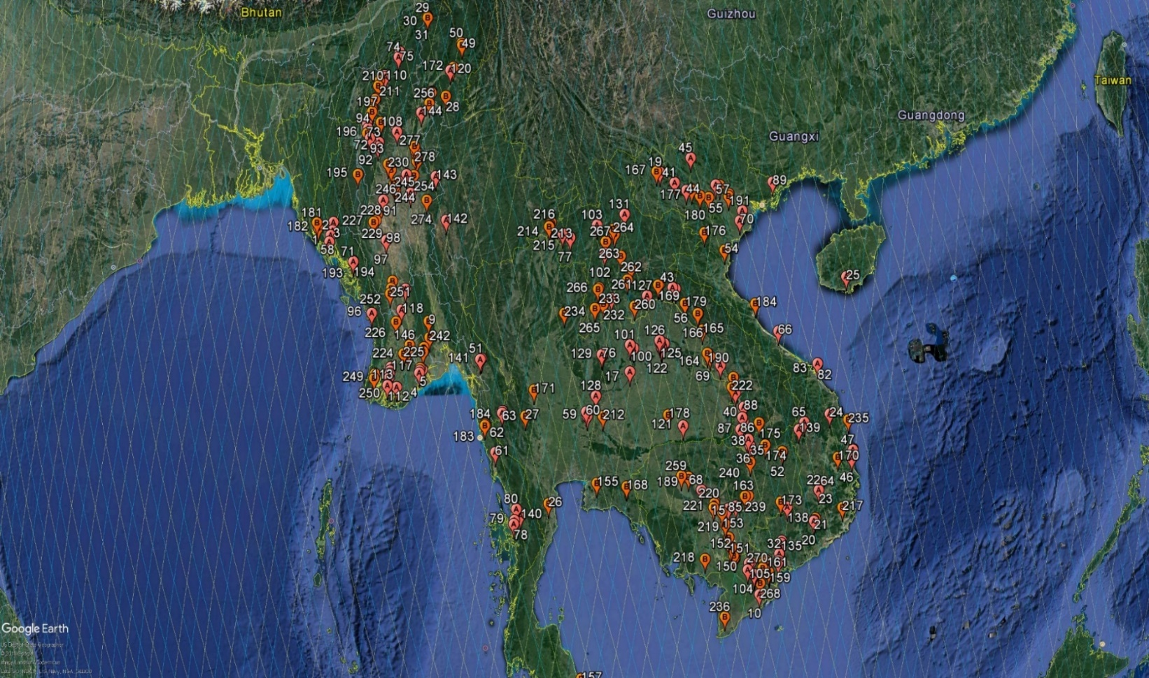

1. MRC hydropower database <https://portal.mrcmekong.org/hydropower/map>

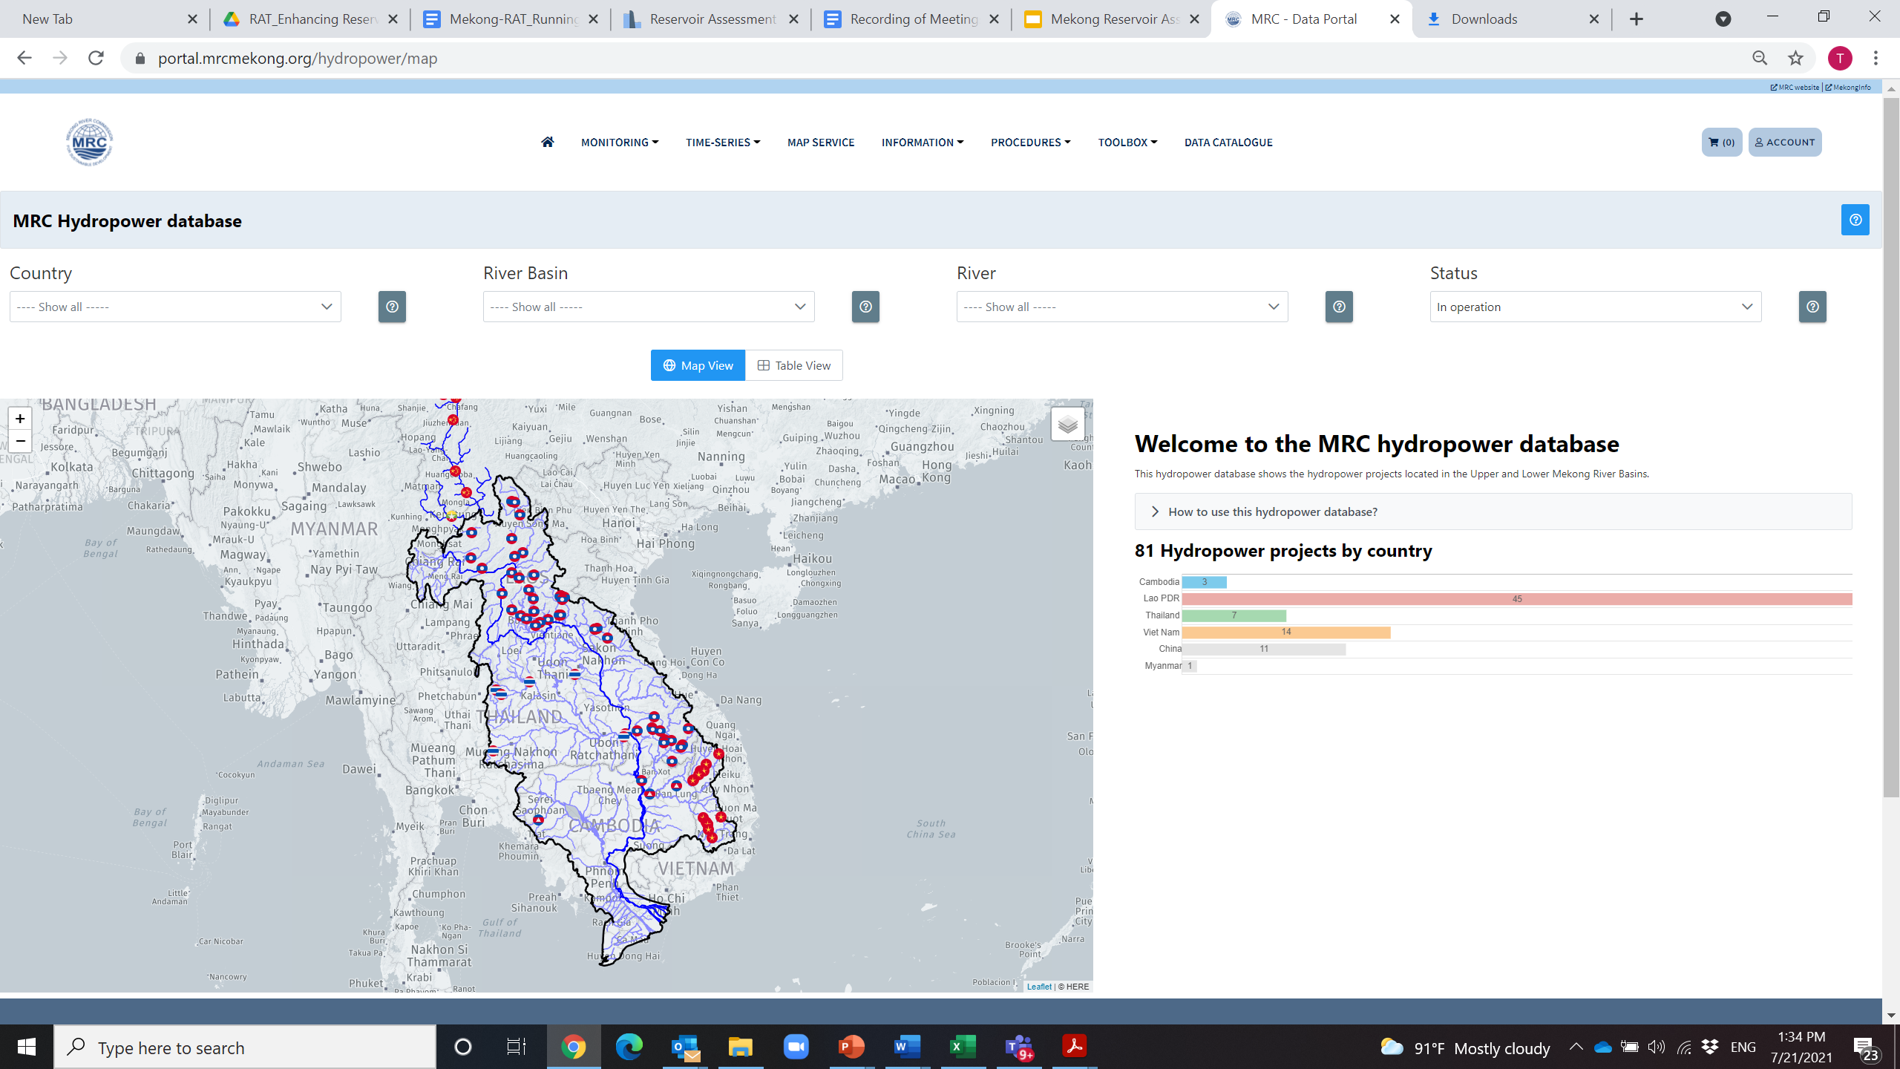

1. MRC irrigation database

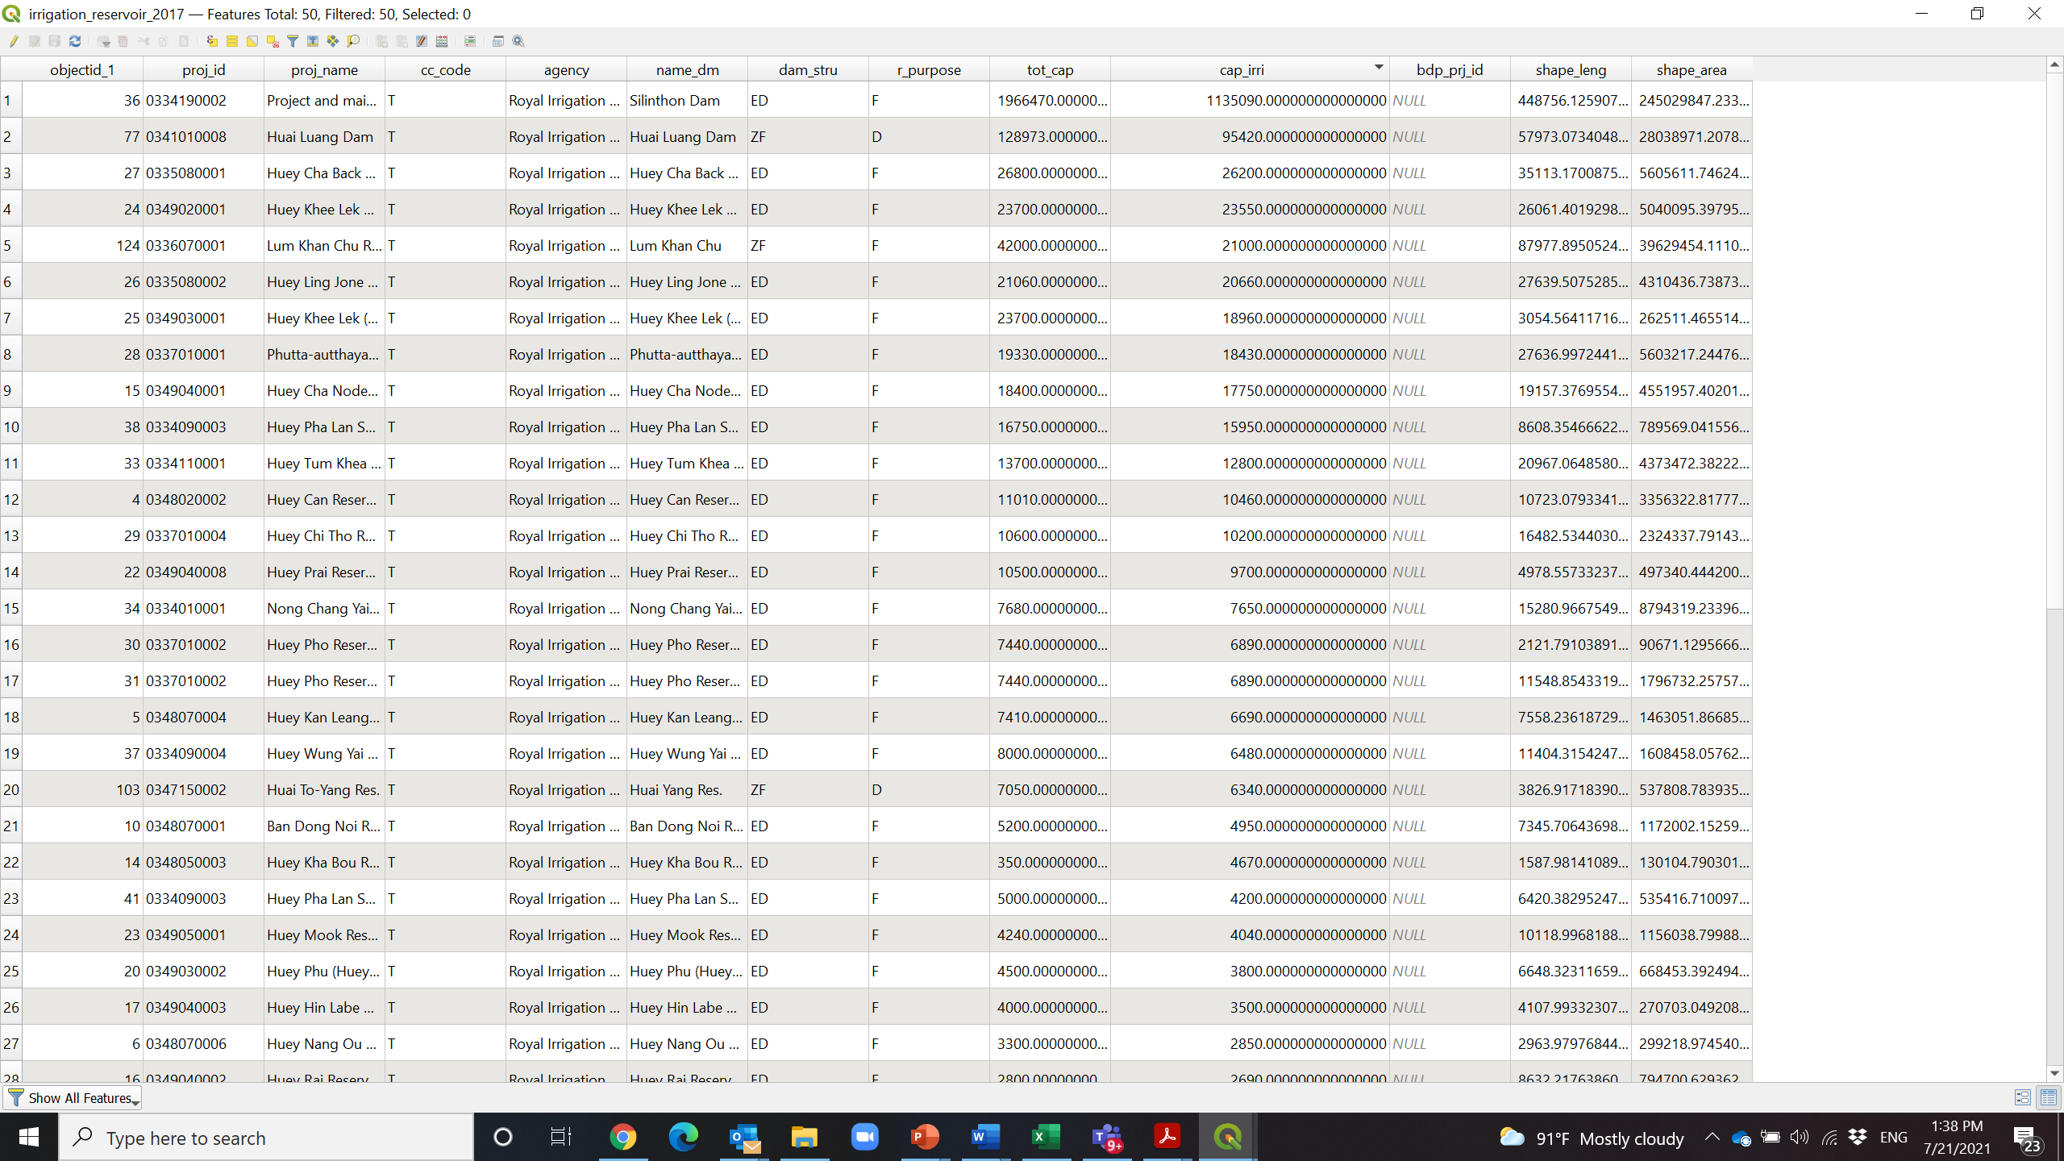

1. MRC Planning Atlas





1. MRC Flow contribution (1986-2000) to consider major tributaries of the Mekong

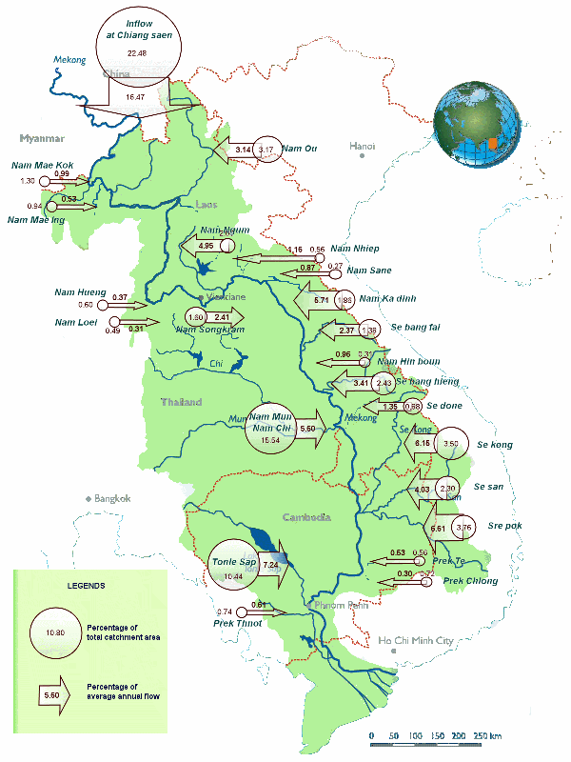

## Results of the selection

According to above criteria and multi-criteria analysis, twelve reservoirs are selected for developing the RAT-Mekong in the testing phase of the development as presented in the Table 1 and Figure 1. The selected reservoirs include hydropower, irrigation, and multi-purpose dams. The live storage varies from 10-4,700 million m3. Variation of reservoir size will demonstrate capability and accuracy of the RAT-Mekong in monitoring changes in reservoir storage, inflow, and outflow.

Based on the consultation with the MRCS team, we received the recommendation to add one more reservoir of the Monkey Cheek Project in Thailand to test and support implementation of MRC’s Drought Management Strategy 2020-2025.

It is noted that the number of existing reservoirs can be added more into the RAT-Mekong in the next stage (or Phase 2) when the member countries satisfy the results and outcomes of the tool applications*.*

Table 1. List of the selected reservoirs

|  |  |  |  |  |  |
| --- | --- | --- | --- | --- | --- |
| No | Project name | Country | River | Purpose | Live storage (mil m3) |
| 1 | Battambang 1 | CAM | Sangker | Multi | 1,040 |
| 2 | Lower Sesan 2 | CAM | Se San | Hydropower | 379.4 |
| 3 | Phumi Svay Chrum | CAM |  | Irrigation | 180 |
| 4 | Nam Ngum 1 | LAO | Nam Ngum | Hydropower | 4,700 |
| 5 | Nam Theun 2 | LAO | Nam Theun | Hydropower | 3,378.4 |
| 6 | Nam Mang 3 | LAO | Nam Mang | Multi | 45 |
| 7 | Lam Pao | THA | Lam Pao/Huai Yang | Irrigation | 1,980 |
| 8 | Siridhorn | THA | Lam Dom Noi | Multi | 1,135 |
| 9 | Ubol Ratana | THA | Nam Pong | Multi | 1,695 |
| 10 | Nam Ton | THA | Nam Ton | Monkey Cheek Project | 41 |
| 11 | Sesan 4 | VN | Se San | Hydropower | 264.16 |
| 12 | Sre Pok 4 | VN | Sre Pok | Hydropower | 10.11 |
| 13 | Yali | VN | Se San | Hydropower | 779.02 |

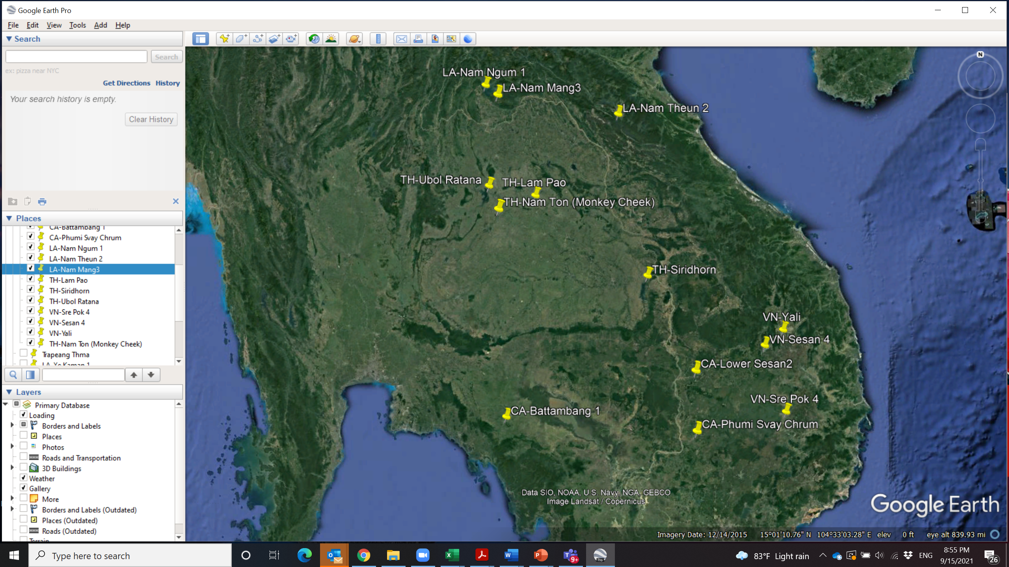

Figure 1. Location of the selected reservoirs in the Member Countries

# Design of web-interface (1st mockup)

Figure 2 below presents the 1st design of the web-interface of the RAT-Mekong. There are three main expected outputs from the tool including estimated inflows, outflows and storage changes at the selected reservoirs. Time series data will be presented every 14 days (bi-weekly). The main functions in the web-interface will include following elements.

* Introduction and guideline for tool applications
* Visualization including maps, graphs and table forms
* Reporting and exporting functions
* Filter function to present the results according to end-user needs.

Main data to be presented will include following information.

* Storage change
* Inflows and outflows
* Reservoir surface area
* Inferred reservoir rule curve
* Basic information of the reservoir characteristics

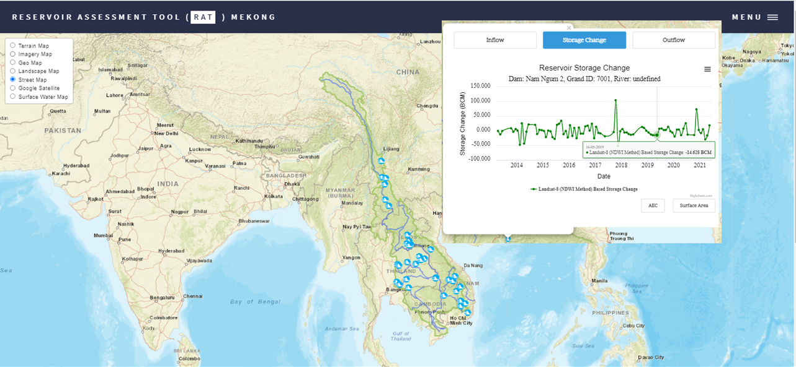

Figure 2. The first design of the web-interface of the RAT-Mekong

# Capacity building programme

The training agenda for the member countries and MRCS team to build knowledge and skill in application of the RAT-Mekong is purposed below.

**Module 1: Overview RAT-Mekong, methodology and modelling**

* Overview of RAT-Mekong including architecture and methodology
* VIC modeling for simulating inflow to reservoir
* Modelling reservoir storage change and outflow
* Area-elevation curve generation from DEM

**Module 2: Web-interface (User-interface)**

* Key functions and visualization
* Exporting the data
* Reporting and writing bulletin

# Work Plan

Table 2 presents the workplan for developing the RAT-Mekong from Oct 2021-May 2022. The full version of the RAT-Mekong prototype will be completed in Feb 2022 for testing. The launching version in the MRC data portal is planned in May 2022. The capacity building program for the Member Countries is planned to organize in Dec 2021 and Feb 2022.

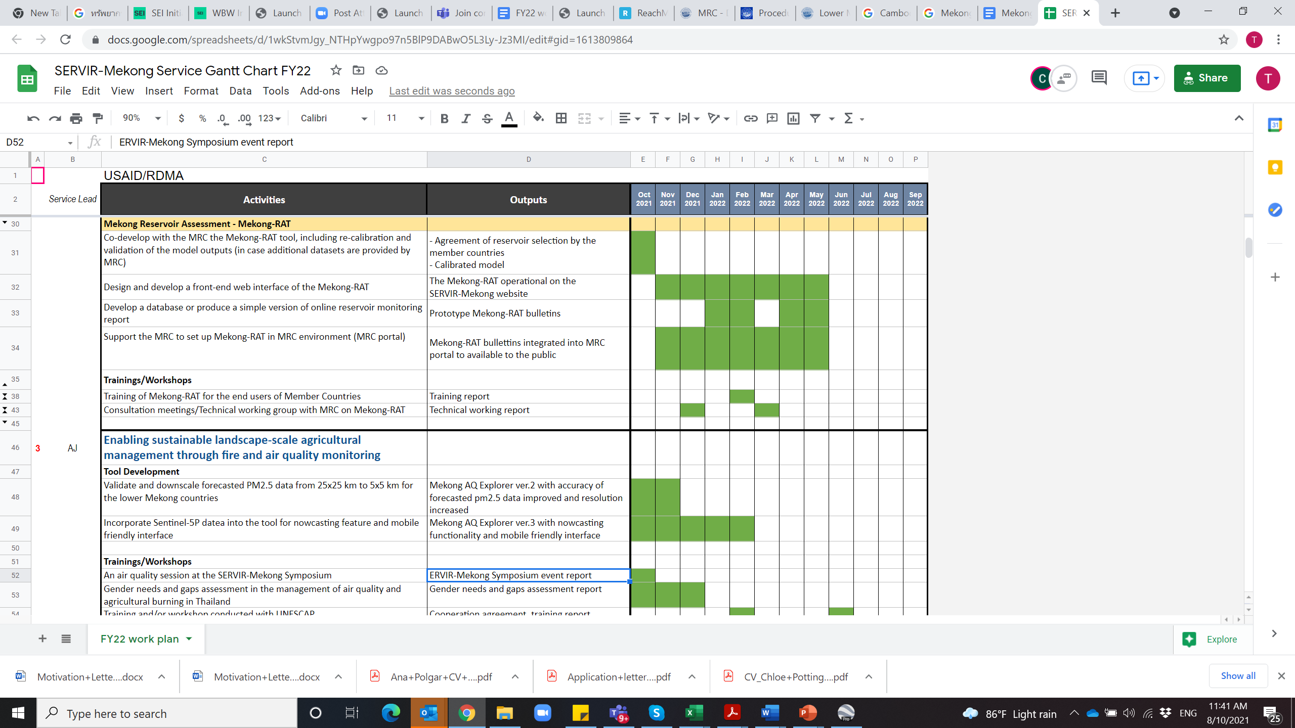

# References

1. Biswas, N., F. Hossain, M. Bonnema, H. Lee, F. Chishtie (2021). A Global Reservoir Assessment Tool for Predicting Hydrologic Impact and Operating Pattern of Existing and Planned Reservoirs, *Environmental Modeling and Software* (available at: <https://saswe.net/publications/RATPaper.pdf>
2. Bonnema, M. and F. Hossain. (2017). Inferring reservoir operating patterns across the Mekong Basin using only space observations, *Water Resources Research*, Vol. 53, pp. 3791–3810, (<http://dx.doi.org/10.1002/2016WR019978>).
3. Bonnema, M., S. Sikder, Y. Miao, X. Chen and F. Hossain, I.A. Pervin, S.M. M. Rahman and H. Lee. (2016). Understanding Satellite-based Monthly-to-Seasonal Reservoir Outflow Estimation as a function of Hydrologic controls *Water Resources Res*., (doi: 10.1002/2015WR017830).
4. WLE. (2021) Mekong Dams Observatory database, Water, Land and Ecosystems in the Greater Mekong Project <https://wle-mekong.cgiar.org/changes/our-research/greater-mekong-dams-observatory/>
5. MRC. (2011) Planning Atlas of the Lower Mekong Basin, Mekong River Commission, Vientiane, Lao PDR.

# Annex A: Comparison analysis of the RAT-Mekong (SERVIR-Mekong) and the Mekong Dam Monitor (Stimson Center)

**Background**

The RAT-Mekong developed by USAID and its SERVIR-Mekong project, is an open-access system for monitoring and forecasting water storage changes, water levels, and water inflow/outflow of dam reservoirs in the Lower Mekong region. The Mekong-RAT caters the needs of the Mekong River Commission (MRC), a regionally mandated agency for water resource management, and supports decision making related to flood and drought management for the Lower Mekong region. It combines remote sensing data with hydrological modeling and presents its outputs on an interactive web platform.

The Mekong Dam Monitor (MDM) has been developed by the State Department and the Stimson Center. It is an online platform which uses satellite imagery, remote sensing data and analyses to provide near-real time reporting of data such as water levels and water storage changes for dam reservoirs in the Upper and Lower Mekong Basins to support hydropower production applications. It was also aimed to increase the transparency and access to reservoir data by the general public.

**Tool Purposes**

The main purposes of the RAT-Mekong and the MDM are different. Target users are also different. The Mekong-RAT has been developed to provide information of reservoir monitoring to assist the MRC in decision making and planning processes to better manage floods and droughts in the Lower Mekong. The Mekong-RAT works with the SERVIR-Mekong flood and drought forecasting tools, together forming a comprehensive package that helps users manage on-going floods and droughts and plan for future events. The MDM is designed for transparent and evidence-based monitoring of Mekong mainstream and major tributary dam operations and downstream hydrological impacts (alterations to hydrological flow) to increase information transparency and access to water data by the public.

Table A1 shows comparisons between the RAT-Mekong and the MDM from different perspectives.

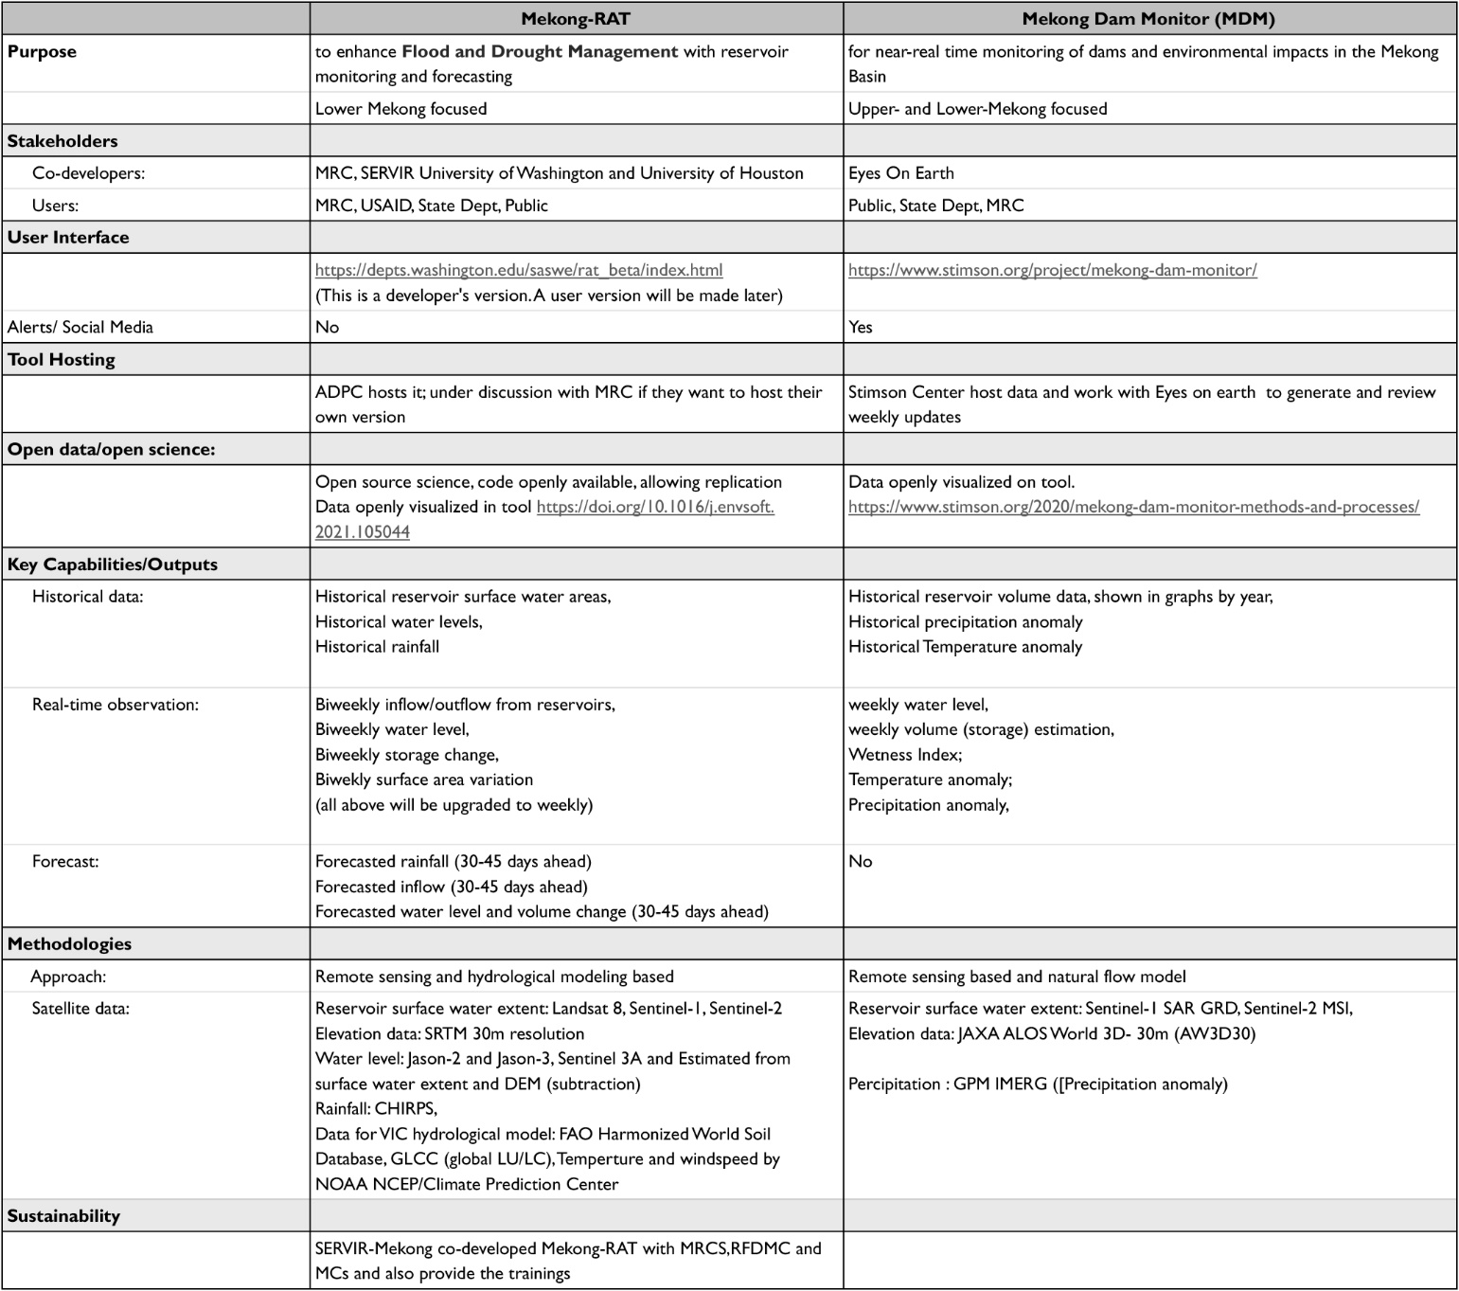Table A1. Comparison between the RAT-Mekong and the MDM

# Annex B: Multi-criteria analysis for ranking and selecting reservoirs

